**Create Eureka Discovery Server and register microservices**

**eureka_discovery_server :-**

**EurekaDiscoveryServerApplication.java :-**

package com.cognizant.eureka_discovery_server;  
  
import org.springframework.boot.SpringApplication;  
import org.springframework.boot.autoconfigure.SpringBootApplication;  
import org.springframework.cloud.netflix.eureka.server.EnableEurekaServer;  
  
@SpringBootApplication  
@EnableEurekaServer  
public class EurekaDiscoveryServerApplication {  
 public static void main(String[] args) {  
 SpringApplication.*run*(EurekaDiscoveryServerApplication.class, args);  
 }  
}

**application.properties :-**

spring.application.name=eureka-discovery-server  
server.port=8761  
eureka.client.register-with-eureka=false  
eureka.client.fetch-registry=false  
  
logging.level.com.netflix.eureka=OFF  
logging.level.com.netflix.discovery=OFF

**pom.xml :-**

<?xml version="1.0" encoding="UTF-8"?>  
<project xmlns="http://maven.apache.org/POM/4.0.0" xmlns:xsi="http://www.w3.org/2001/XMLSchema-instance"  
 xsi:schemaLocation="http://maven.apache.org/POM/4.0.0 https://maven.apache.org/xsd/maven-4.0.0.xsd">  
 <modelVersion>4.0.0</modelVersion>  
 <parent>  
 <groupId>org.springframework.boot</groupId>  
 <artifactId>spring-boot-starter-parent</artifactId>  
 <version>3.5.3</version>  
 <relativePath/> <!-- lookup parent from repository -->  
 </parent>  
 <groupId>com.cognizant</groupId>  
 <artifactId>eureka-discovery-server</artifactId>  
 <version>0.0.1-SNAPSHOT</version>  
 <name>eureka-discovery-server</name>  
 <description>Demo project for Spring Boot</description>  
 <url/>  
 <licenses>  
 <license/>  
 </licenses>  
 <developers>  
 <developer/>  
 </developers>  
 <scm>  
 <connection/>  
 <developerConnection/>  
 <tag/>  
 <url/>  
 </scm>  
 <properties>  
 <java.version>21</java.version>  
 <spring-cloud.version>2025.0.0</spring-cloud.version>  
 </properties>  
 <dependencies>  
 <dependency>  
 <groupId>org.springframework.boot</groupId>  
 <artifactId>spring-boot-starter-web</artifactId>  
 </dependency>  
 <dependency>  
 <groupId>org.springframework.cloud</groupId>  
 <artifactId>spring-cloud-starter-netflix-eureka-server</artifactId>  
 </dependency>  
  
 <dependency>  
 <groupId>org.springframework.boot</groupId>  
 <artifactId>spring-boot-devtools</artifactId>  
 <scope>runtime</scope>  
 <optional>true</optional>  
 </dependency>  
 <dependency>  
 <groupId>org.springframework.boot</groupId>  
 <artifactId>spring-boot-starter-test</artifactId>  
 <scope>test</scope>  
 </dependency>  
 </dependencies>  
 <dependencyManagement>  
 <dependencies>  
 <dependency>  
 <groupId>org.springframework.cloud</groupId>  
 <artifactId>spring-cloud-dependencies</artifactId>  
 <version>${spring-cloud.version}</version>  
 <type>pom</type>  
 <scope>import</scope>  
 </dependency>  
 </dependencies>  
 </dependencyManagement>  
  
 <build>  
 <plugins>  
 <plugin>  
 <groupId>org.springframework.boot</groupId>  
 <artifactId>spring-boot-maven-plugin</artifactId>  
 </plugin>  
 </plugins>  
 </build>  
  
</project>

**Output :-**

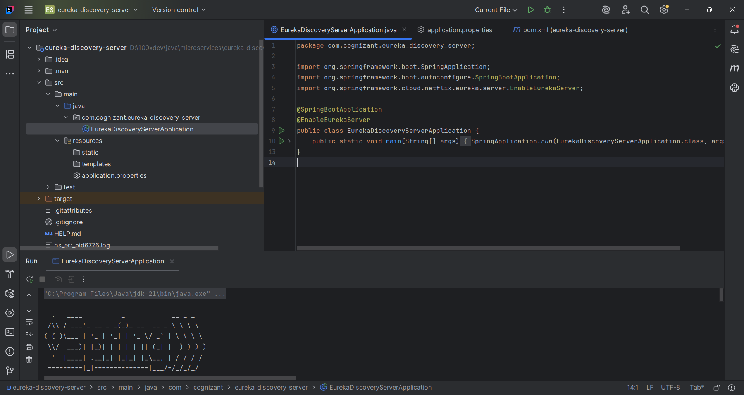

**Account-service :-**

**AccountServiceApplication.java :-**

package com.cognizant.account_service;  
  
import org.springframework.boot.SpringApplication;  
import org.springframework.boot.autoconfigure.SpringBootApplication;  
import org.springframework.cloud.client.discovery.EnableDiscoveryClient;  
  
@SpringBootApplication  
@EnableDiscoveryClient  
  
public class AccountServiceApplication {  
  
 public static void main(String[] args) {  
 SpringApplication.*run*(AccountServiceApplication.class, args);  
 }  
  
}

**application.properties :-**

spring.application.name=account-service  
server.port=8081  
  
eureka.client.service-url.defaultZone=http://localhost:8761/eureka

**pom.xml :-**

<?xml version="1.0" encoding="UTF-8"?>  
<project xmlns="http://maven.apache.org/POM/4.0.0" xmlns:xsi="http://www.w3.org/2001/XMLSchema-instance"  
 xsi:schemaLocation="http://maven.apache.org/POM/4.0.0 https://maven.apache.org/xsd/maven-4.0.0.xsd">  
 <modelVersion>4.0.0</modelVersion>  
 <parent>  
 <groupId>org.springframework.boot</groupId>  
 <artifactId>spring-boot-starter-parent</artifactId>  
 <version>3.5.3</version>  
 <relativePath/> <!-- lookup parent from repository -->  
 </parent>  
 <groupId>com.cognizant</groupId>  
 <artifactId>account-service</artifactId>  
 <version>0.0.1-SNAPSHOT</version>  
 <name>account-service</name>  
 <description>Demo project for Spring Boot</description>  
 <url/>  
 <licenses>  
 <license/>  
 </licenses>  
 <developers>  
 <developer/>  
 </developers>  
 <scm>  
 <connection/>  
 <developerConnection/>  
 <tag/>  
 <url/>  
 </scm>  
 <properties>  
 <java.version>21</java.version>  
 <spring-cloud.version>2025.0.0</spring-cloud.version>  
 </properties>  
 <dependencies>  
  
 <dependency>  
 <groupId>org.springframework.boot</groupId>  
 <artifactId>spring-boot-starter-web</artifactId>  
 </dependency>  
 <dependency>  
 <groupId>org.springframework.cloud</groupId>  
 <artifactId>spring-cloud-starter-netflix-eureka-client</artifactId>  
 </dependency>  
  
 <dependency>  
 <groupId>org.springframework.boot</groupId>  
 <artifactId>spring-boot-devtools</artifactId>  
 <scope>runtime</scope>  
 <optional>true</optional>  
 </dependency>  
 <dependency>  
 <groupId>org.springframework.boot</groupId>  
 <artifactId>spring-boot-starter-test</artifactId>  
 <scope>test</scope>  
 </dependency>  
 </dependencies>  
 <dependencyManagement>  
 <dependencies>  
 <dependency>  
 <groupId>org.springframework.cloud</groupId>  
 <artifactId>spring-cloud-dependencies</artifactId>  
 <version>${spring-cloud.version}</version>  
 <type>pom</type>  
 <scope>import</scope>  
 </dependency>  
 </dependencies>  
 </dependencyManagement>  
  
 <build>  
 <plugins>  
 <plugin>  
 <groupId>org.springframework.boot</groupId>  
 <artifactId>spring-boot-maven-plugin</artifactId>  
 </plugin>  
 </plugins>  
 </build>  
  
</project>

**Output :-**

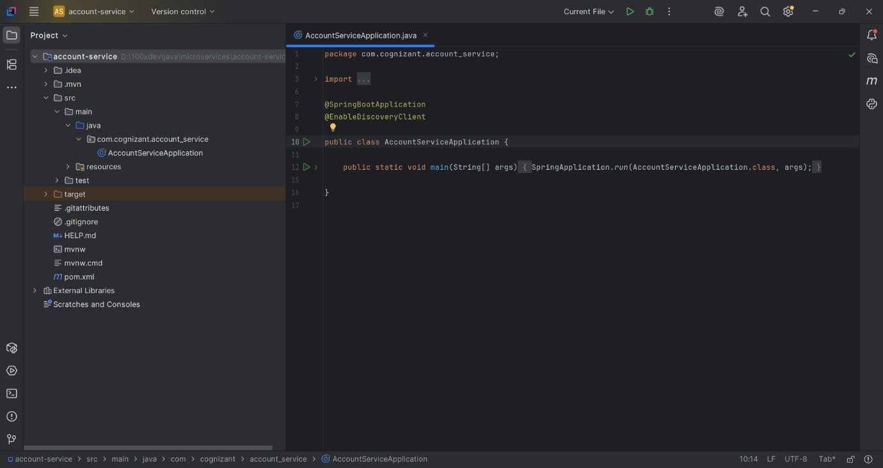

**Loan-service :-**

**LoanServiceApplication.java :-**

package com.cognizant.loan_service;  
  
import org.springframework.boot.SpringApplication;  
import org.springframework.boot.autoconfigure.SpringBootApplication;  
import org.springframework.cloud.client.discovery.EnableDiscoveryClient;  
  
@SpringBootApplication  
@EnableDiscoveryClient  
public class LoanServiceApplication {  
  
 public static void main(String[] args) {  
 SpringApplication.*run*(LoanServiceApplication.class, args);  
 }  
  
}

**application.properties :-**

spring.application.name=loan-service  
server.port=8090  
eureka.client.service-url.defaultZone=http://localhost:8761/eureka

**pom.xml :-**

<?xml version="1.0" encoding="UTF-8"?>  
<project xmlns="http://maven.apache.org/POM/4.0.0" xmlns:xsi="http://www.w3.org/2001/XMLSchema-instance"  
 xsi:schemaLocation="http://maven.apache.org/POM/4.0.0 https://maven.apache.org/xsd/maven-4.0.0.xsd">  
 <modelVersion>4.0.0</modelVersion>  
 <parent>  
 <groupId>org.springframework.boot</groupId>  
 <artifactId>spring-boot-starter-parent</artifactId>  
 <version>3.5.3</version>  
 <relativePath/> <!-- lookup parent from repository -->  
 </parent>  
 <groupId>com.cognizant</groupId>  
 <artifactId>loan-service</artifactId>  
 <version>0.0.1-SNAPSHOT</version>  
 <name>loan-service</name>  
 <description>Demo project for Spring Boot</description>  
 <url/>  
 <licenses>  
 <license/>  
 </licenses>  
 <developers>  
 <developer/>  
 </developers>  
 <scm>  
 <connection/>  
 <developerConnection/>  
 <tag/>  
 <url/>  
 </scm>  
 <properties>  
 <java.version>21</java.version>  
 <spring-cloud.version>2025.0.0</spring-cloud.version>  
 </properties>  
 <dependencies>  
 <dependency>  
 <groupId>org.springframework.boot</groupId>  
 <artifactId>spring-boot-starter-web</artifactId>  
 </dependency>  
 <dependency>  
 <groupId>org.springframework.cloud</groupId>  
 <artifactId>spring-cloud-starter-netflix-eureka-client</artifactId>  
 </dependency>  
  
 <dependency>  
 <groupId>org.springframework.boot</groupId>  
 <artifactId>spring-boot-devtools</artifactId>  
 <scope>runtime</scope>  
 <optional>true</optional>  
 </dependency>  
 <dependency>  
 <groupId>org.springframework.cloud</groupId>  
 <artifactId>spring-cloud-starter-netflix-eureka-client</artifactId>  
 </dependency>  
  
 <dependency>  
 <groupId>org.springframework.boot</groupId>  
 <artifactId>spring-boot-starter-test</artifactId>  
 <scope>test</scope>  
 </dependency>  
 </dependencies>  
 <dependencyManagement>  
 <dependencies>  
 <dependency>  
 <groupId>org.springframework.cloud</groupId>  
 <artifactId>spring-cloud-dependencies</artifactId>  
 <version>${spring-cloud.version}</version>  
 <type>pom</type>  
 <scope>import</scope>  
 </dependency>  
 </dependencies>  
 </dependencyManagement>  
  
 <build>  
 <plugins>  
 <plugin>  
 <groupId>org.apache.maven.plugins</groupId>  
 <artifactId>maven-compiler-plugin</artifactId>  
 <version>3.11.0</version> <!-- latest safe version -->  
 <configuration>  
 <source>21</source>  
 <target>21</target>  
 </configuration>  
 </plugin>  
 </plugins>  
 </build>  
  
  
</project>

**Output :-**

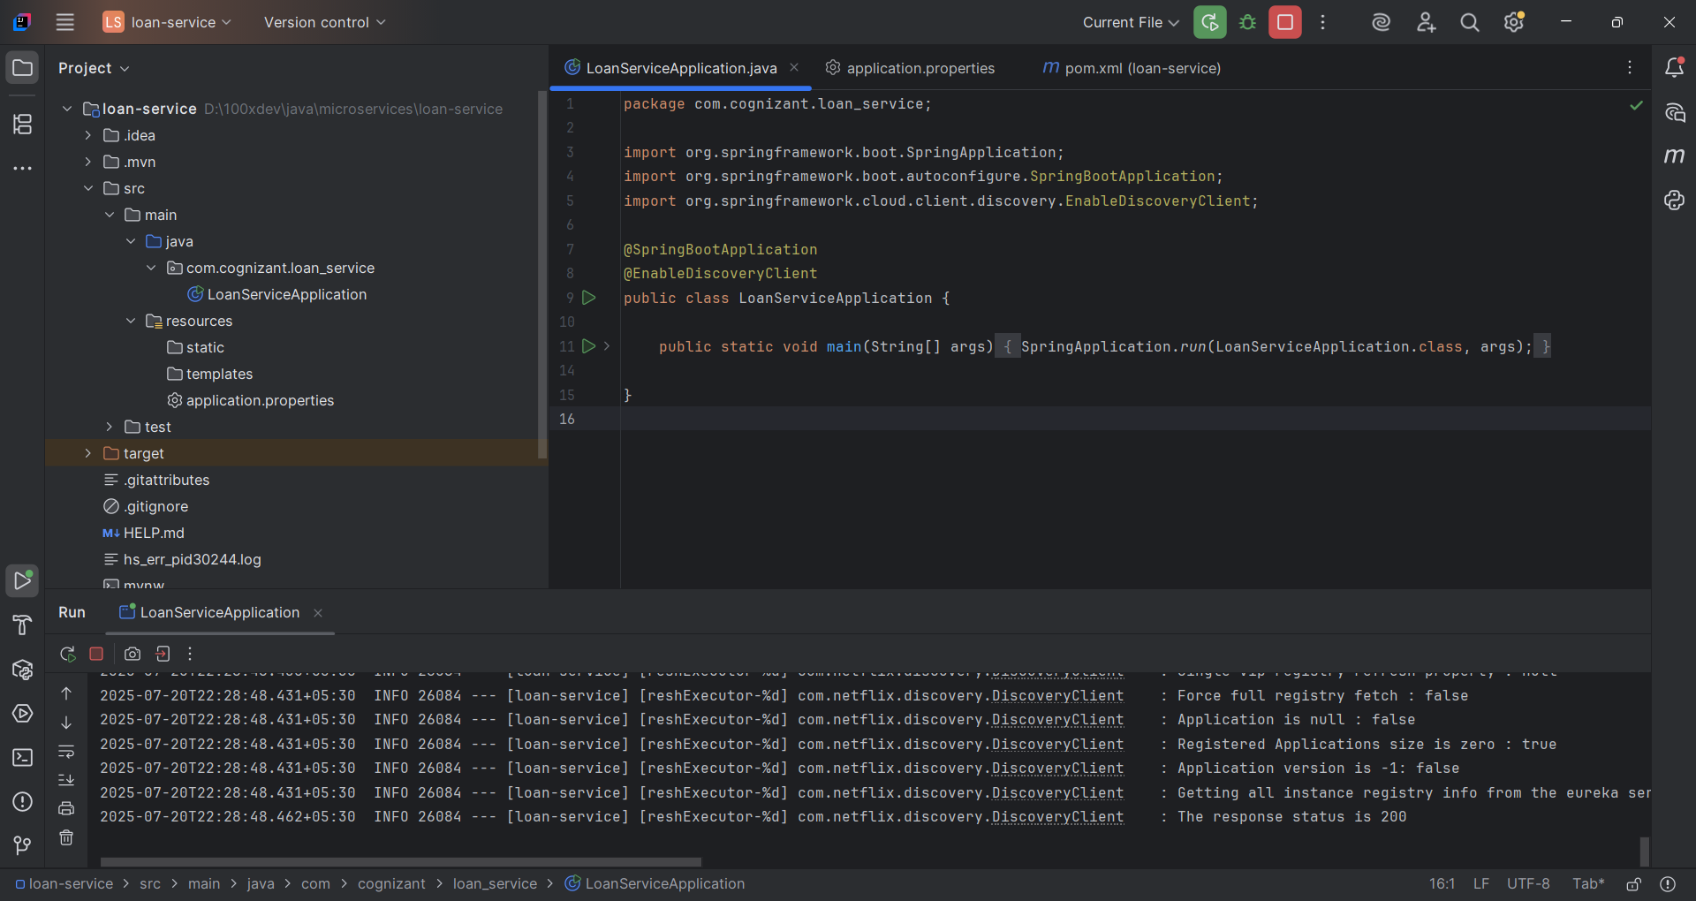

**Greet-service :-**

**GreetServiceApplication.java :-**

package com.cognizant.greet_service;

import org.springframework.boot.SpringApplication;

import org.springframework.boot.autoconfigure.SpringBootApplication;

import org.springframework.cloud.client.discovery.EnableDiscoveryClient;

@SpringBootApplication

@EnableDiscoveryClient

public class GreetServiceApplication {

public static void main(String[] args) {

SpringApplication.run(GreetServiceApplication.class, args);

}

}

**GreetController.java :-**

package com.cognizant.greet_service.controller;  
  
import org.springframework.web.bind.annotation.GetMapping;  
import org.springframework.web.bind.annotation.RestController;  
  
@RestController  
public class GreetController {  
  
 @GetMapping("/greet")  
 public String greet() {  
 return "Hello World";  
 }  
}

**application.properties :-**

spring.application.name=greet-service  
server.port=8082  
  
eureka.client.service-url.defaultZone=http://localhost:8761/eureka  
server.servlet.context-path=/greet-service

**pom.xml :-**

<?xml version="1.0" encoding="UTF-8"?>  
<project xmlns="http://maven.apache.org/POM/4.0.0" xmlns:xsi="http://www.w3.org/2001/XMLSchema-instance"  
 xsi:schemaLocation="http://maven.apache.org/POM/4.0.0 https://maven.apache.org/xsd/maven-4.0.0.xsd">  
 <modelVersion>4.0.0</modelVersion>  
 <parent>  
 <groupId>org.springframework.boot</groupId>  
 <artifactId>spring-boot-starter-parent</artifactId>  
 <version>3.5.3</version>  
 <relativePath/> <!-- lookup parent from repository -->  
 </parent>  
 <groupId>com.cognizant</groupId>  
 <artifactId>greet-service</artifactId>  
 <version>0.0.1-SNAPSHOT</version>  
 <name>greet-service</name>  
 <description>Demo project for Spring Boot</description>  
 <url/>  
 <licenses>  
 <license/>  
 </licenses>  
 <developers>  
 <developer/>  
 </developers>  
 <scm>  
 <connection/>  
 <developerConnection/>  
 <tag/>  
 <url/>  
 </scm>  
 <properties>  
 <java.version>21</java.version>  
 <spring-cloud.version>2025.0.0</spring-cloud.version>  
 </properties>  
 <dependencies>  
 <dependency>  
 <groupId>org.springframework.boot</groupId>  
 <artifactId>spring-boot-starter-web</artifactId>  
 </dependency>  
 <dependency>  
 <groupId>org.springframework.cloud</groupId>  
 <artifactId>spring-cloud-starter-netflix-eureka-client</artifactId>  
 </dependency>  
  
 <dependency>  
 <groupId>org.springframework.boot</groupId>  
 <artifactId>spring-boot-devtools</artifactId>  
 <scope>runtime</scope>  
 <optional>true</optional>  
 </dependency>  
 <dependency>  
 <groupId>org.springframework.boot</groupId>  
 <artifactId>spring-boot-starter-test</artifactId>  
 <scope>test</scope>  
 </dependency>  
 </dependencies>  
 <dependencyManagement>  
 <dependencies>  
 <dependency>  
 <groupId>org.springframework.cloud</groupId>  
 <artifactId>spring-cloud-dependencies</artifactId>  
 <version>${spring-cloud.version}</version>  
 <type>pom</type>  
 <scope>import</scope>  
 </dependency>  
 </dependencies>  
 </dependencyManagement>  
  
 <build>  
 <plugins>  
 <plugin>  
 <groupId>org.springframework.boot</groupId>  
 <artifactId>spring-boot-maven-plugin</artifactId>  
 </plugin>  
 </plugins>  
 </build>  
  
</project>

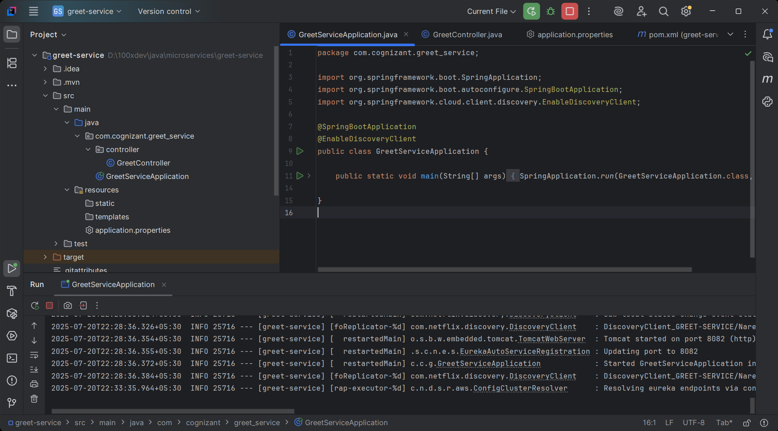

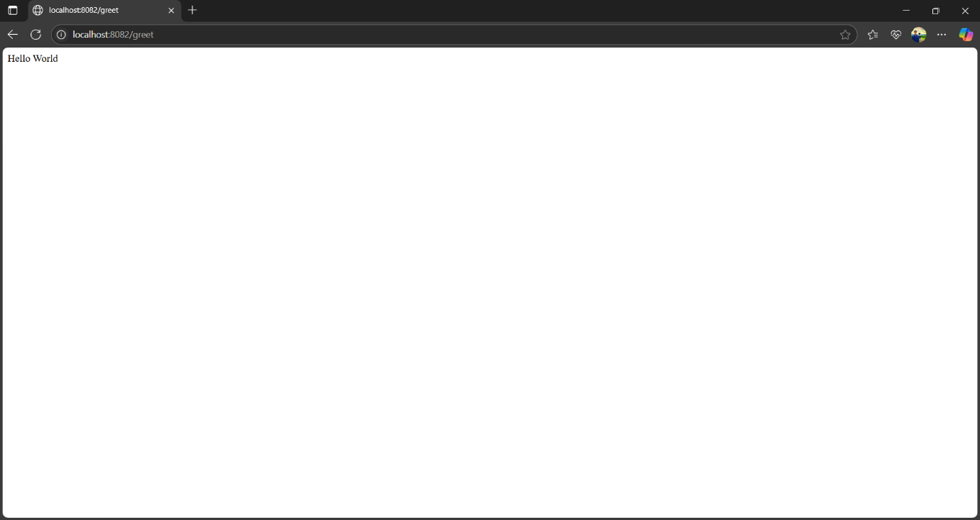

**Api-gateway :-**

**ApiGatewayApplication.java :-**

package com.cognizant.api_gateway;  
  
import org.springframework.boot.SpringApplication;  
import org.springframework.boot.autoconfigure.SpringBootApplication;  
import org.springframework.cloud.client.discovery.EnableDiscoveryClient;  
  
@SpringBootApplication  
@EnableDiscoveryClient  
public class ApiGatewayApplication {  
  
 public static void main(String[] args) {  
 SpringApplication.*run*(ApiGatewayApplication.class, args);  
 }  
  
}

**LogFilter.java :-**

package com.cognizant.api_gateway.filter;  
  
import org.slf4j.Logger;  
import org.slf4j.LoggerFactory;  
import org.springframework.cloud.gateway.filter.GlobalFilter;  
import org.springframework.core.Ordered;  
import org.springframework.stereotype.Component;  
import org.springframework.web.server.ServerWebExchange;  
import reactor.core.publisher.Mono;  
import org.springframework.cloud.gateway.filter.GatewayFilterChain;  
  
@Component  
public class LogFilter implements GlobalFilter, Ordered {  
  
 private static final Logger *log* = LoggerFactory.*getLogger*(LogFilter.class);  
  
 @Override  
 public Mono<Void> filter(ServerWebExchange exchange, GatewayFilterChain chain) {  
 String method = exchange.getRequest().getMethod().name();  
  
 String uri = exchange.getRequest().getURI().toString();  
 String clientIP = exchange.getRequest().getRemoteAddress() != null ?  
 exchange.getRequest().getRemoteAddress().getAddress().getHostAddress() : "unknown";  
  
 *log*.info("Incoming request → [{}] {} from IP: {}", method, uri, clientIP);  
  
 return chain.filter(exchange);  
 }  
  
 @Override  
 public int getOrder() {  
 return -1; // Highest precedence  
 }  
}

**application.properties :-**

spring.application.name=api-gateway  
server.port=9090  
  
# Config Server  
spring.config.import=optional:configserver:http://localhost:8888  
  
# Spring Cloud Gateway configuration  
spring.cloud.gateway.server.webflux.discovery.locator.enabled=true  
spring.cloud.gateway.server.webflux.discovery.locator.lower-case-service-id=true  
  
# Optional for Eureka discovery  
eureka.client.service-url.defaultZone=http://localhost:8761/eureka/  
  
# Required for WebFlux gateway  
spring.main.web-application-type=reactive  
logging.level.com.cognizant.api_gateway.filter=INFO

**pom.xml :-**

<project xmlns="http://maven.apache.org/POM/4.0.0" xmlns:xsi="http://www.w3.org/2001/XMLSchema-instance" xsi:schemaLocation="http://maven.apache.org/POM/4.0.0 https://maven.apache.org/xsd/maven-4.0.0.xsd">  
 <modelVersion>4.0.0</modelVersion>  
 <parent>  
 <groupId>org.springframework.boot</groupId>  
 <artifactId>spring-boot-starter-parent</artifactId>  
 <version>3.5.3</version>  
 <relativePath/>  
 <!-- lookup parent from repository -->  
 </parent>  
 <groupId>com.cognizant</groupId>  
 <artifactId>api-gateway</artifactId>  
 <version>0.0.1-SNAPSHOT</version>  
 <name>api-gateway</name>  
 <description>Demo project for Spring Boot</description>  
 <url/>  
 <licenses>  
 <license/>  
 </licenses>  
 <developers>  
 <developer/>  
 </developers>  
 <scm>  
 <connection/>  
 <developerConnection/>  
 <tag/>  
 <url/>  
 </scm>  
 <properties>  
 <java.version>21</java.version>  
 <spring-cloud.version>2025.0.0</spring-cloud.version>  
 </properties>  
 <dependencies>  
 <dependency>  
 <groupId>org.springframework.cloud</groupId>  
 <artifactId>spring-cloud-starter-config</artifactId>  
 </dependency>  
 <dependency>  
 <groupId>org.springframework.cloud</groupId>  
 <artifactId>spring-cloud-starter-netflix-eureka-client</artifactId>  
 </dependency>  
 <dependency>  
 <groupId>org.springframework.cloud</groupId>  
 <artifactId>spring-cloud-starter-gateway</artifactId>  
 </dependency>  
 <dependency>  
 <groupId>org.springframework.boot</groupId>  
 <artifactId>spring-boot-devtools</artifactId>  
 <scope>runtime</scope>  
 <optional>true</optional>  
 </dependency>  
 <dependency>  
 <groupId>org.springframework.boot</groupId>  
 <artifactId>spring-boot-starter-test</artifactId>  
 <scope>test</scope>  
 </dependency>  
 </dependencies>  
  
 <dependencyManagement>  
 <dependencies>  
 <dependency>  
 <groupId>org.springframework.cloud</groupId>  
 <artifactId>spring-cloud-dependencies</artifactId>  
 <version>${spring-cloud.version}</version>  
 <type>pom</type>  
 <scope>import</scope>  
 </dependency>  
 </dependencies>  
 </dependencyManagement>  
 <build>  
 <plugins>  
 <plugin>  
 <groupId>org.springframework.boot</groupId>  
 <artifactId>spring-boot-maven-plugin</artifactId>  
 </plugin>  
 </plugins>  
 </build>  
</project>

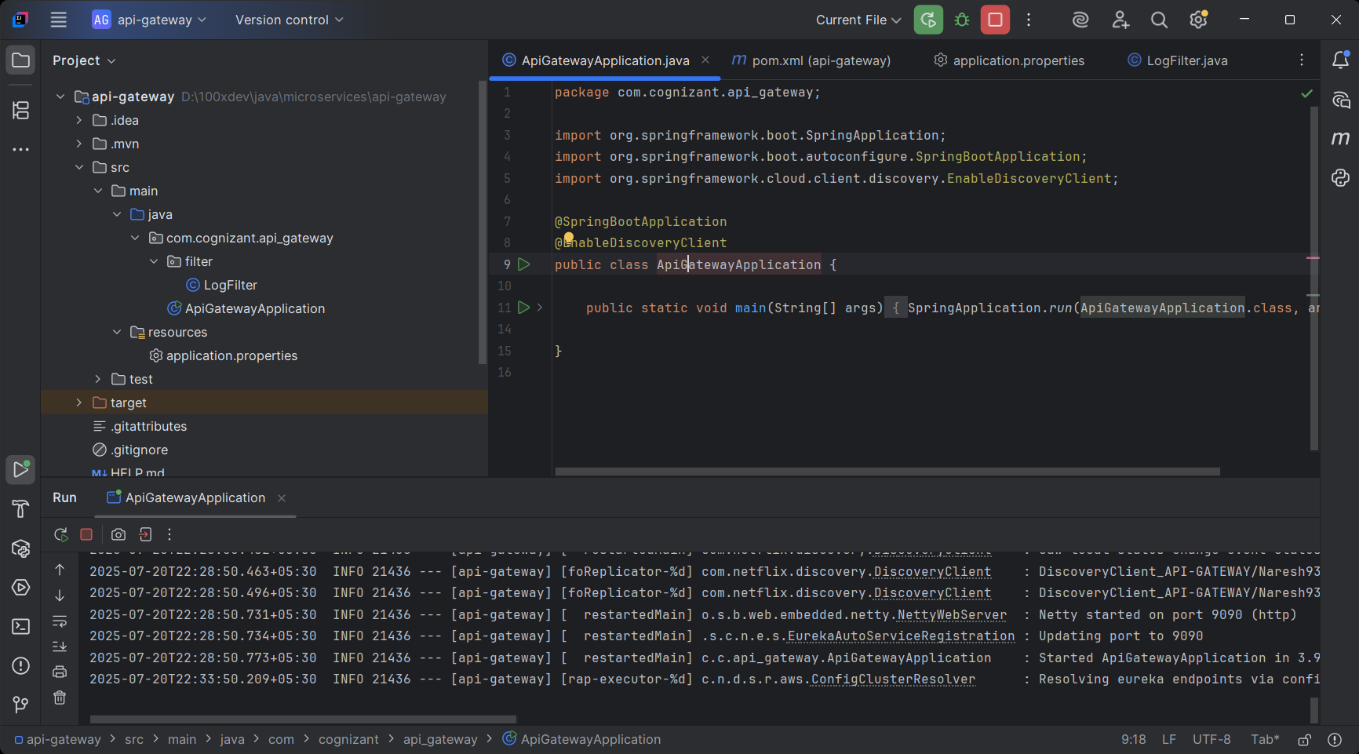

**Output :-**

